Profiles - Start Lightroom Editing with New Color and B+W Profiles
Adobe introduced powerful new profiles to Lightroom Classic. These profiles provide a starting point for your images in terms of color and tonality.
Camera profiles have been available for application to raw photos for years, way down in the Camera Calibration panel in the bottom right of Lightroom Classic’s Develop module. In addition to the Adobe Standard default profile, there have been profiles to choose from that mimic your camera’s picture modes.
Adobe has greatly expanded the set of available profiles specifically for raw files, introduced creative profiles for all file types, and moved profile selection to the top of the Basic panel to increase awareness of it and to encourage application towards the beginning of one’s workflow.
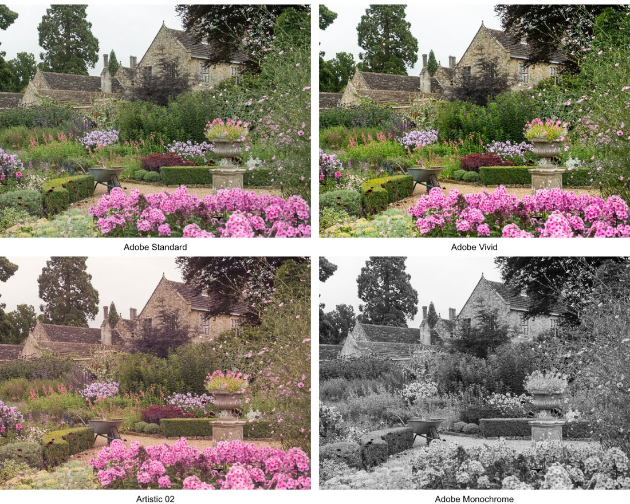

Applying Profiles:
- In the Basic Panel of the Develop Module, locate the Profile area (below the Treatment area) at the top.
- Use the Profile pop-up menu to quickly access Adobe profiles and the profiles that you've marked as favorites.
- To browse and apply other creative profiles in the Profile Browser, either choose Browse from the Profile pop-up menu or click the Profile Browser icon on the right 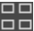

Adobe Raw (Only): Significantly improve color rendering and provide a good starting point for editing your raw images.
- Adobe Color: Adobe Color has replaced Adobe Standard as the default profile for all raw images imported from now on. Just as with Adobe Standard, the intent is to give images from all cameras a standard look and feel that is generally pleasing, but Adobe Color has been modernized with a bit more contrast and saturation, and more pop to warm colors specifically while protecting skin tones.
- Adobe Monochrome will be applied by default when you convert your image to black and white. This new profile produces a better spread of tones than the old default conversion of applying Adobe Standard and an auto-mix B&W slider solution. Additional B&W profiles are available, some of which replicate colored filters.
- Adobe Landscape is more saturated than Adobe Color, particularly in the blues and greens. The tonal range is compressed so you have more headroom for expansion (takes advantage of wide dynamic range) and the skin protection is removed.
- Adobe Neutral reduces contrast and color boosts to give you as much editing headroom as possible. This one is not designed to make your image look great without further editing.
- Adobe Portrait is optimized for pleasing skin tones of all shades. Contrast is also lower compared to Adobe Color.
- Adobe Standard, the old default. Intended to make photos from different cameras look as similar as possible.
- Adobe Vivid is designed to produce a vibrant image that looks great right away. It has higher contrast and saturation than Adobe Color. It’s great for sunsets!
Camera Matching Profiles (RAW only) Previously in the Camera Calibration section. Continue to be available, camera make and model specific, matching in-camera picture styles. Choose one of these if you liked how your image looked on the back of the camera: Camera Faithful, Landscape, Neutral, Portrait, Standard
Legacy Profiles (RAW only – B&W): Displays legacy profiles that were also provided in earlier versions of LR. Adobe Standard B&W, Camera Faithful B&W, Landscape B&W, Neutral B&W, Portrait B&W, Standard B&W.

Creative Profiles - For Any File Type (RAW, JPEG, TIFF, PSD, PNG):
These Creative Profiles are designed to create a certain style or look. Some of them use 3D lookup tables (LUTs) to map one color space into another, which allows them to create looks that would not be possible using the sliders available in the Develop module. One advantage of using a Creative Profile over a preset is that a profile does not change Develop Slider values – so they don’t wipe out prior slider values, and slider editing can be performed on top of them.
Once you apply a Creative Profile, you’ll see an Amount slider with which you can adjust the profile intensity (Amount slider is not available with RAW related Profiles – used with Creative Profiles only)
Here are the category descriptions from Adobe:
- Artistic: more edgy, with stronger color shifts
- B&W: designed to optimize tonality shifts needed for high impact black and white work.
- Modern: designed to create unique effects that fit in with current photography styles.
- Vintage: replicate the effects of analog imagery (look more like film photos)

Accessing Profiles in Lightroom Classic
- In the Basic panel in the Develop module, click on the dropdown next to “Profile:” to choose Adobe Color (default color), Adobe Monochrome (default black and white), or a profile from your Favorites.
- Click on the four-square icon in the profile section to open the Profile Browser to see the full collection of profiles.
- The Amount Slider to adjust profile intensity will be available for creative profiles only (Artistic, B/W, Modern, Vintage; not Adobe Raw, Camera Matching or Legacy).
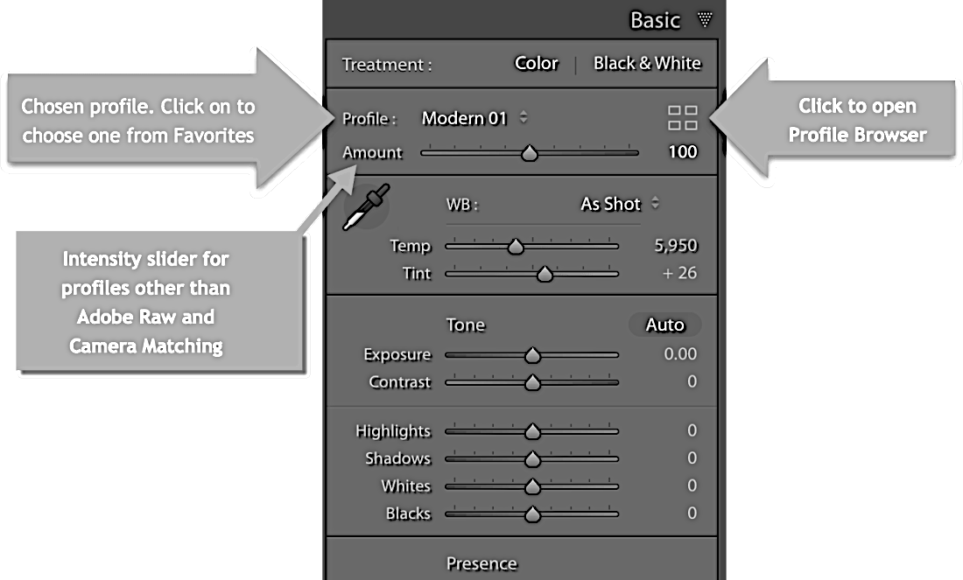

Profile Browser details:
- Click on the Grid/Large/List dropdown to choose a display mode.
- Hover over a profile to see a full-size preview in Lightroom’s main image window.
- Click on a profile to apply it. (Note that this puts a step in History.)
- To add a profile to the Favorites section, click on the star in its thumbnail or next to it (in list view). Click again to remove it.
- To close the Profile Browser, click on the Close button, or Hit Enter/Return or Esc.
- NOTE: To expand width of Profile Browser panel (helpful in Grid View), hover over the edge of the panel to get the double arrow and drag to the left. Hold down Alt or Option key to drag it even more to the left.
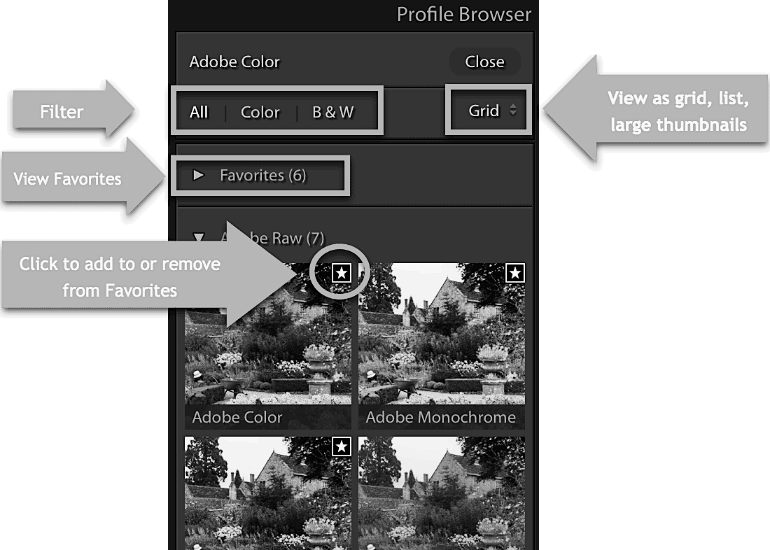

Tips:
- There is no “correct” profile to use. Just choose the one you like best. It can be easily changed later at any point.
- In general, apply profiles at the start of editing unless the image is too bright or too dark to make that decision on.
- The “All Color B&W” area is a filter by which you can select just the “Color” profiles, the “B&W” profiles or “All” profiles.
- If you want to delete a profile from “Favorites”, go into the Favorites section and click on the Star again.

Note: Difference between “Presets” and “Profiles”:
- A Profile will not change the sliders while a Preset will.
- You can apply a profile on top of pre-existing editing without fear of wiping that editing out.
- Presets do affect pre-existing editing.
- Profiles are the better choice if effect is similar.
- One advantage of Presets is that you can tell exactly how they affect the Sliders which you can’t do with Profiles
- Every image must have a profile and only one profile.
- You don’t need to apply any Preset to images or you can apply one or more Presets to any image.
- Profiles can create effects that can’t be created with just LR sliders and tools so they increase the power of LR.
- Move the pointer over any profile to preview its effect in your photo. Click the Profile to apply it to your photo.
- To go back to the Basic panel, click Close at the upper-right corner of the Profile Browser panel.

